**BÀI TẬP THỰC HÀNH**

**Học phần: Phát triển ứng dụng web**

**Khoa: CNTT – HVKTMM**

**Chương 5 – Lab21.**

**Review database and multiLanguage**

Create the website had the database such as the following figure:

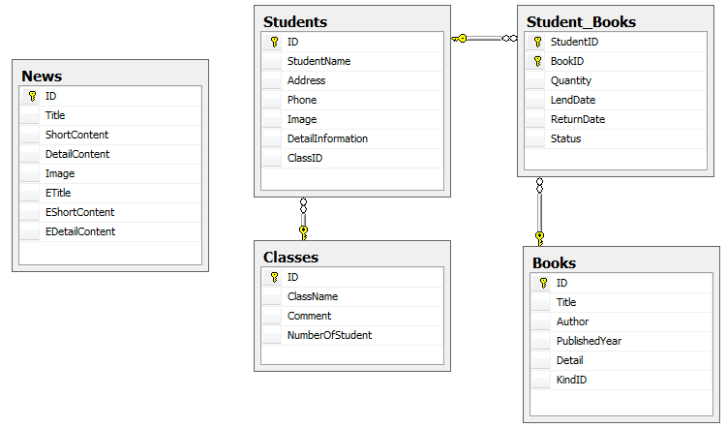

The website has functions such as describing below:

**Module1**:

Multi-language for News management modules (including 3 pages: updateNews.aspx, listNews.aspx, detailNews.aspx). For example, the interface of listNews page below:

* When clicking to English button, the page is such as the following figure:

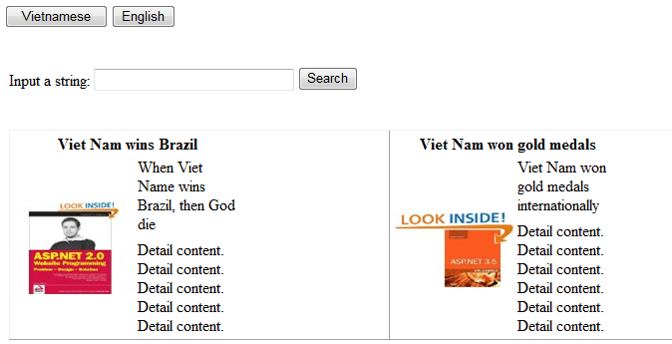

* When clicking Vietnamese button, , the page is such as below:

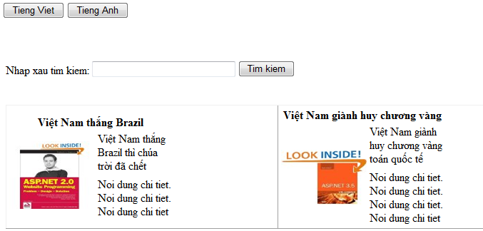

**Module2:**

* Including 3 pages: updateStudent.aspx: allow to insert, delete, update information of classes, student in the class. listStudent.aspx: display list students and small image. detailStudent.aspx: view detail information of the selected student (from listStudent page) with large image and list all of other students in the same class.
* For example, the updateStudent page below:

